Quinzical   
User Manual

An in-depth guide on how to play Quinzical

Contents

Introduction 3

Install Instruction 3

Main Menu 4

Game Module 5

Starting a Game 5

Playing the Game 5

Answering questions 6

Finishing the Game 7

Practice Module 8

Settings 9

# Introduction

Quinzical is an interactive application that aims to help the player improve their understanding about Aotearoa, New Zealand.  
This application is designed for Linux systems.

# Install Instruction

## First time installation

(The installation of the application might require the assistance of a person with knowledge on operating in Linux)

2. To get started, first install **festival** and **festlex-oald** text-to-speech dependencies using the commands below.

sudo apt-get install festival

sudo apt-get install festlex-oald

3. Place the .jar file, run_game.sh script, and Quinzical.txt file which contains the questions, into a new directory of your choice.

4. Open the terminal and change the current working directory to the directory created above.

5. To run the game, give executable permissions to the script file.

chmod +x run_game.sh

6. Run the game using this command. Please do note that this script is tailored for the second version of the SE206 image, given that you have installed the voices provided by Catherine.

./run_game.sh

# Main Menu

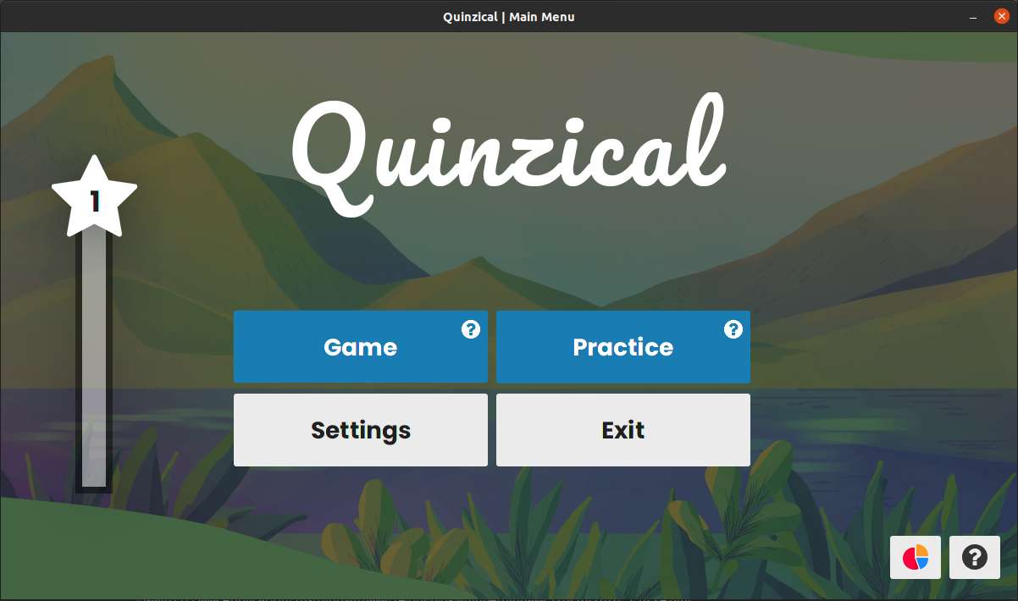

This is the main menu of the game. You can access most of the features of Quinzical right here.   
The vertical bar on the left is your Experience, or EXP. This shows the effort you have spent in game. You can gain EXP by playing Game and answering the questions correctly. The faster you can on getting the correct answer the more EXP you will get.

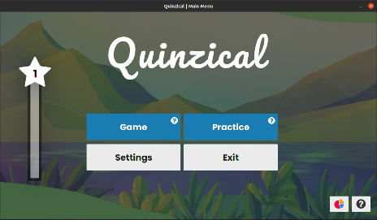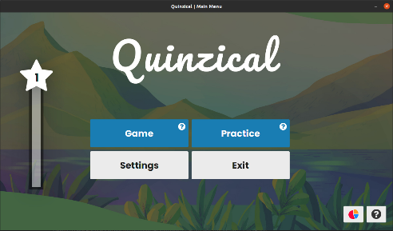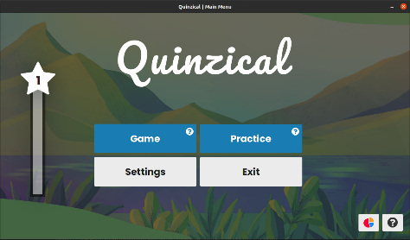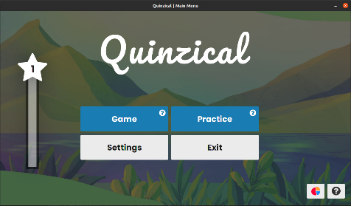To start playing the game, press the **Game** button.  
To practice the questions, press the **Practice** button.  
To change the settings of the game, press the **Settings** button.  
To leave the program, press the **Exit** button.

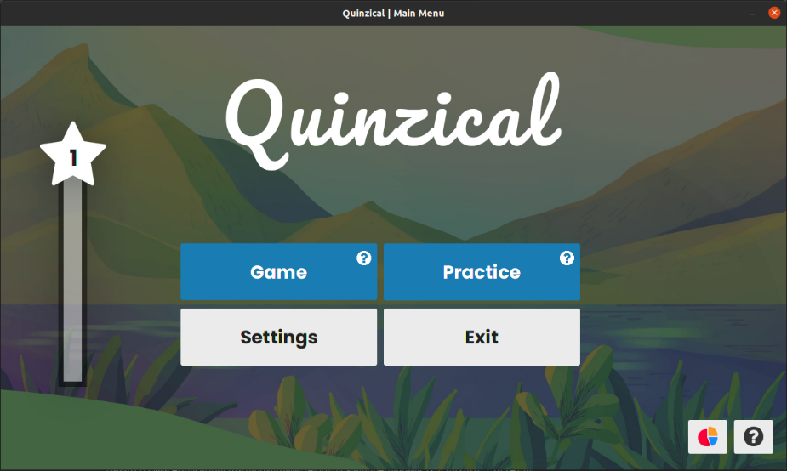On the bottom right corner of the main menu, there are two small buttons.  
The **Statistics** button will take you to your statistics page.

# Game Module

## Starting a Game

If it is the first time you open the game, this screen will be presented to you:

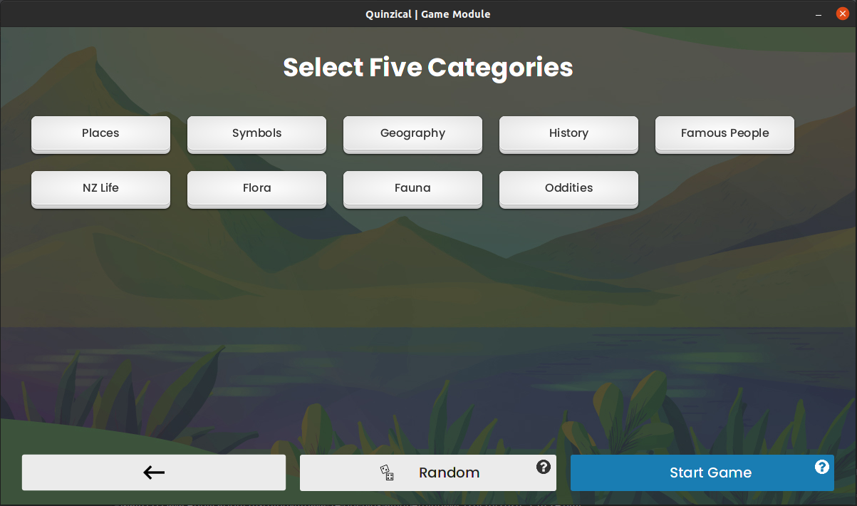

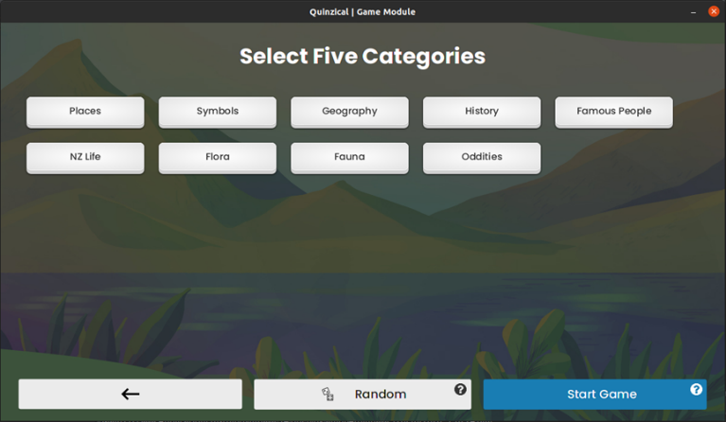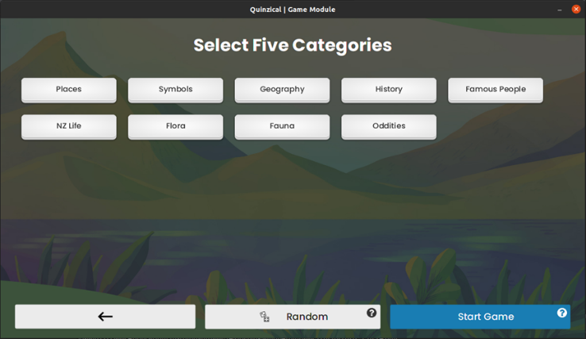In this screen, the player can select 5 categories regarding New Zealand, or they can use the **Random** button, then the game will automatically choose 5 random questions selected for the user to start the game.  
The user can press **Start Game** to start playing the game.

## Playing the Game

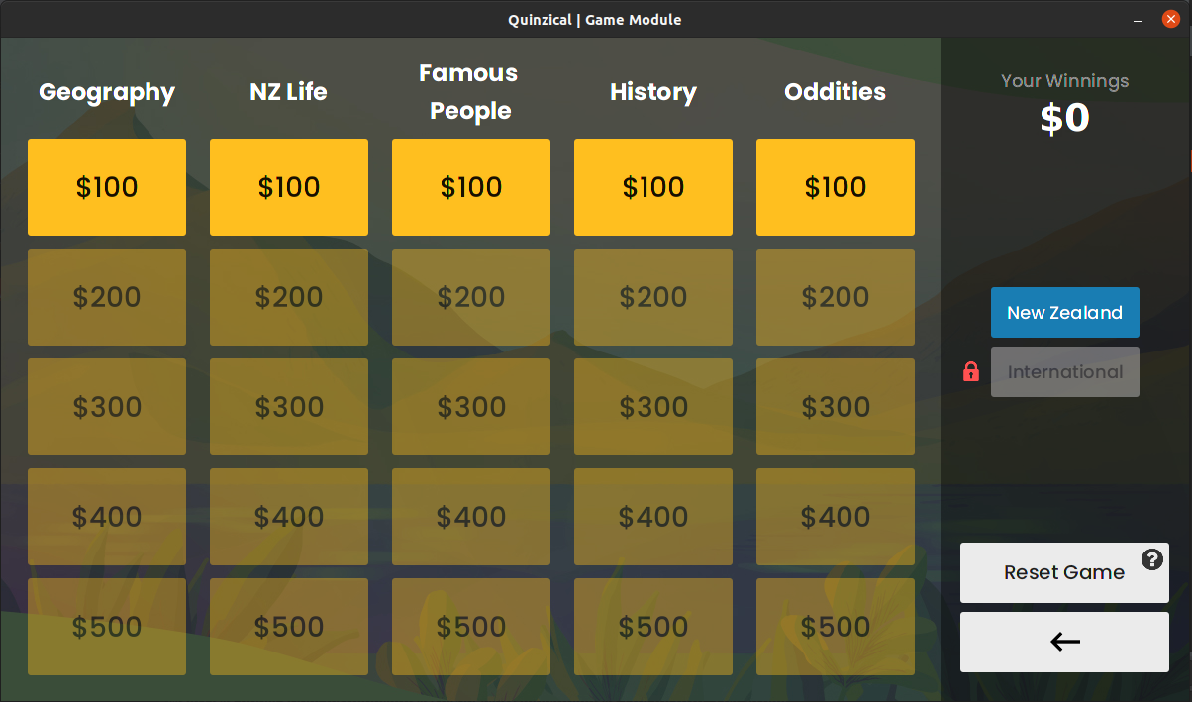

This is the game screen of Quinzical. The top right shows your current winning in this Game.  
Here, you can select what question you want to attempt for each Category, starting from the lowest price. The higher-priced questions would be available after you attempted the lower-priced questions.

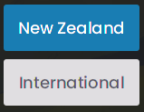The locked button on the right is the International questions. These are extra question that are about trivia around the world. The International questions will be unlocked when the questions in 2 or more categories are all answered.

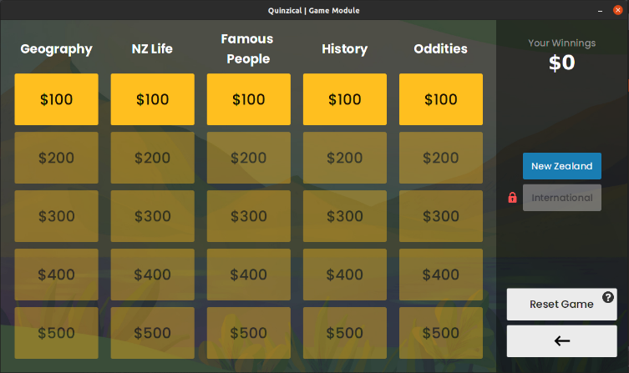If you want to restart he game fromt the beginnig, you can use the **Reset Game** button to reset the game and start over.

## Answering questions

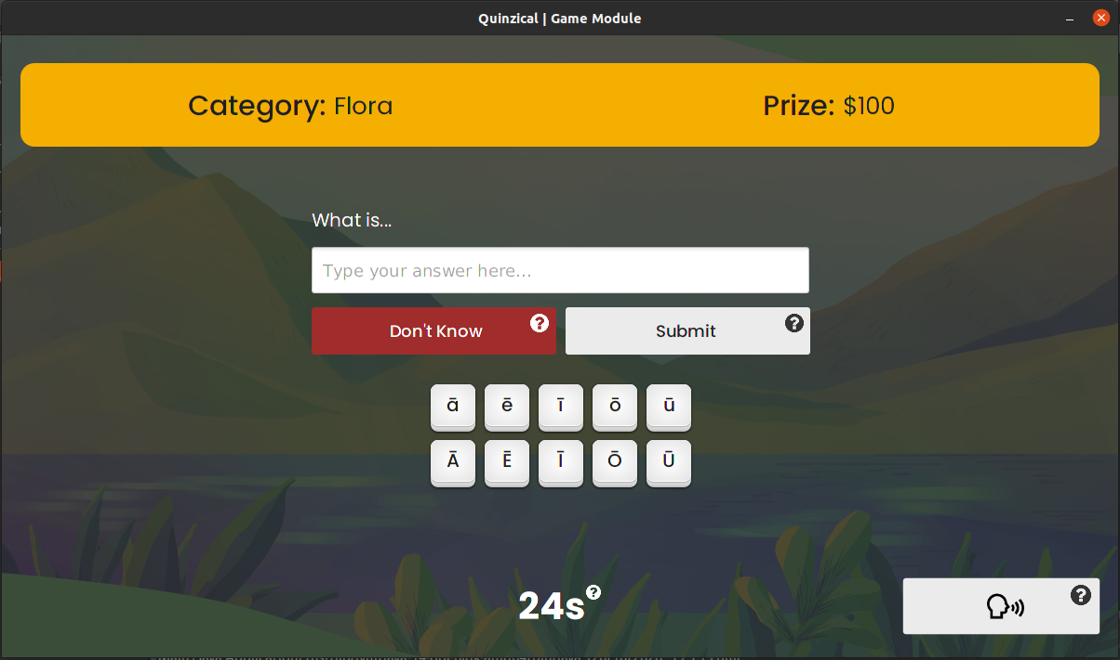

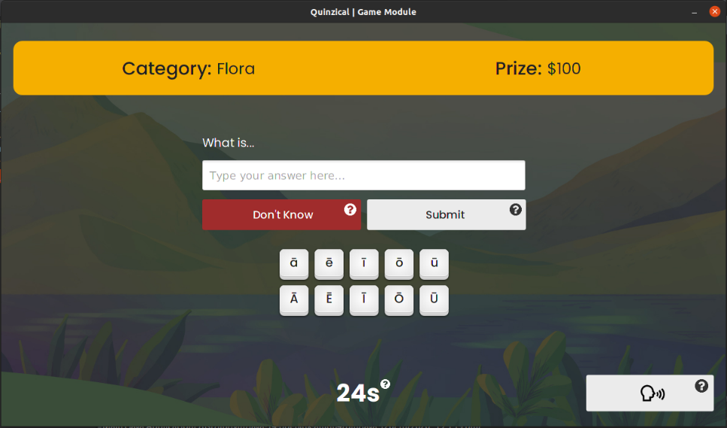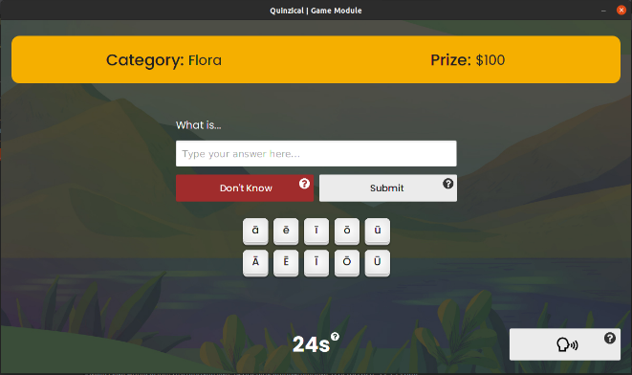This is the screen when a question is selected. You can type in your answer in the text box in the middle after hearing the app speak out the question. The button in the bottom right corner will play the question again if you missed it. After the answer is typed in, you can either press the **Submit** button or press enter to check your answer.

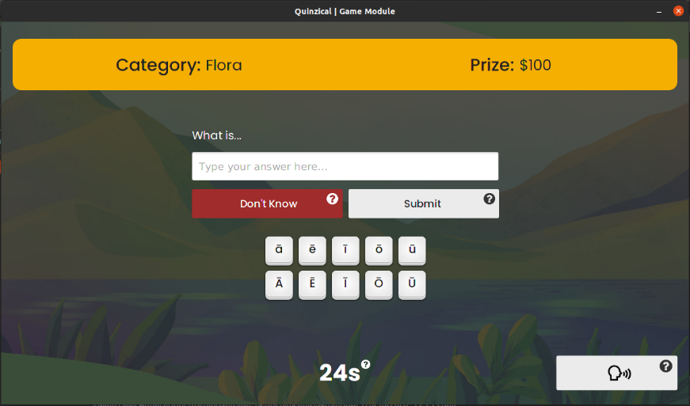If you really have no idea about the answer, you can instead press the **Don’t Know** button, you will not get the winnings or the EXP from the question, but you are honest to yourself.

Under the text field is the macron keyboards. If you answer involves macrons but you don’t know how to type them, you can use these buttons to assist you answering the question.

Be careful though, the question has a timer, and you need to answer before the timer runs out. The faster you finish the question, the more EXP you will get from that question.

After the question is answered or the timer ran out, you will be shown if you got it right or not. You can leave this screen and back to the categories using the button on the bottom left.

## Finishing the Game

When you answered all of the questions in the game, the prize screen will be showed to you  
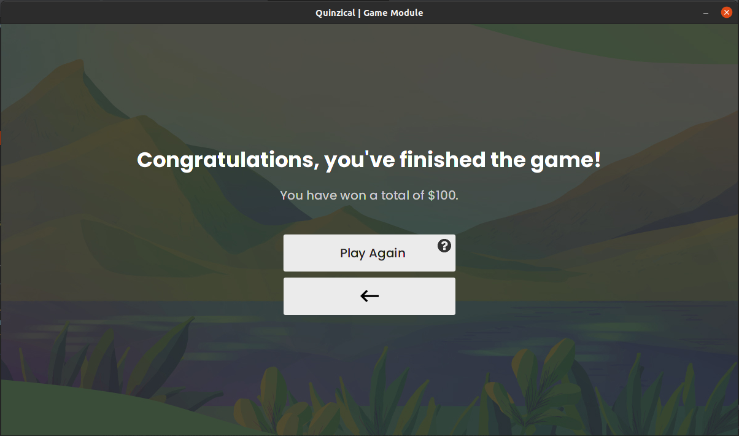

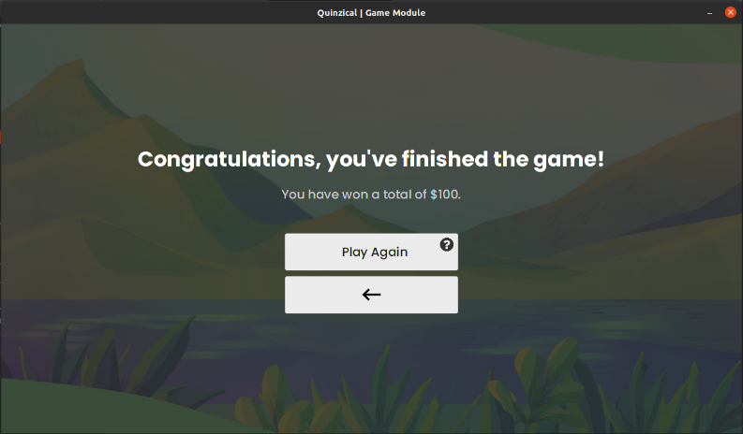You can see the winning you earned during this game, and can go back to main menu, or reset the game by using the **Play Again** button to play the game with fresh sets of questions.

# Practice Module

## Selecting Category

The Practice button on the main menu will bring you to this Practice menu.

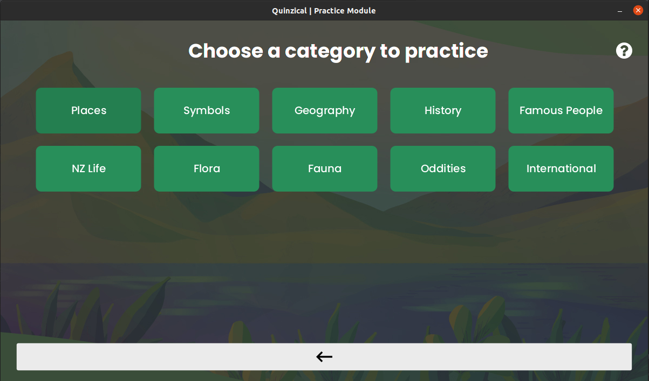

Here, you can select the category that you want to practice. The question will be randomly selected from the database.

# Settings

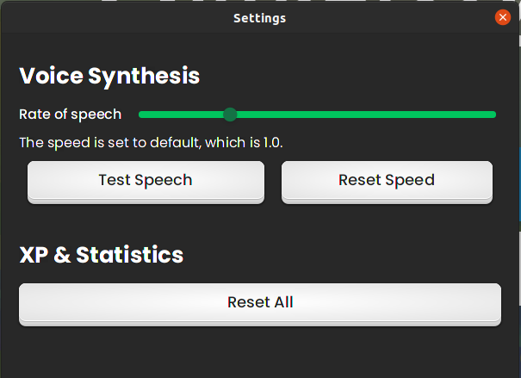

If you click the settings button in the main menu, this popup would be shown.

* The slider up top is used to control the speed of speech, dragging left and right would change the speed.
* 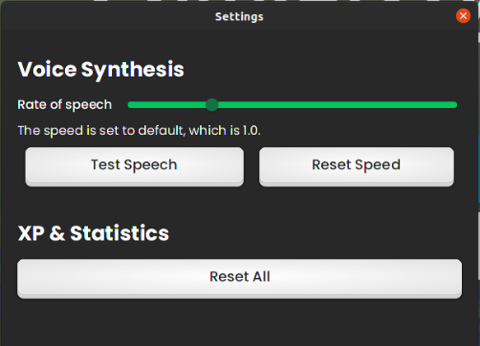The **Test Speech** button could be pressed to get a preview on how fast the speaking is.
* The **Reset Speed** button will reset the speed back to 1.0.
* 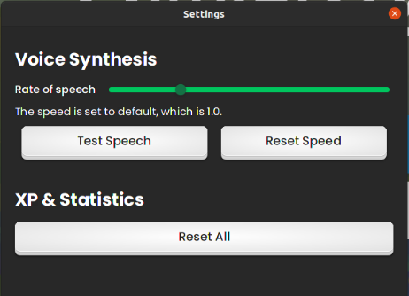The **Reset All** button will reset all the progressions of the player, including EXP earned, and the statistics like games played and total winnings across games.

# Statistics

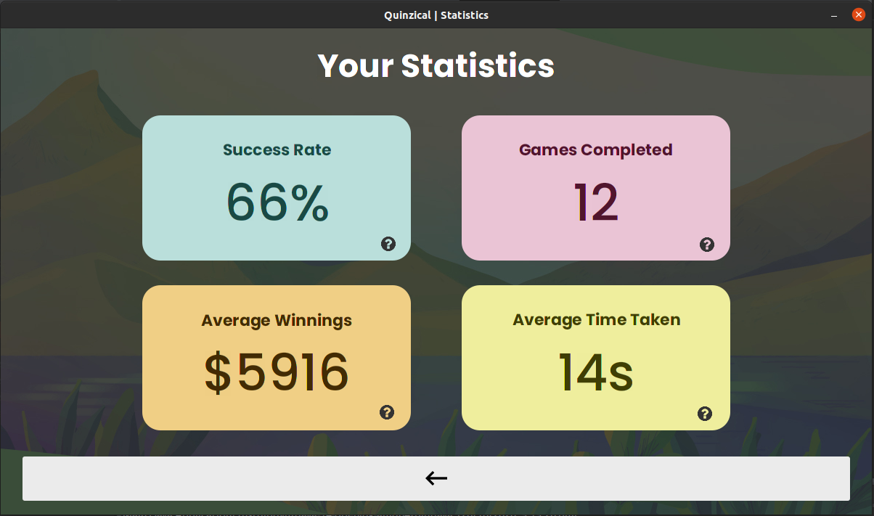 In the Statistics screen, you can see how you performed in Games module.

* On the top left, this is the percentage of you getting a question correct in games.
* On the top right, this is the number of Games that you have finished until there is no questions left in a game.
* On the bottom left, this is the average winning that you earned across all games you have played.
* On the bottom right, this is the average time that you took to answer a question correctly.

You can go back to the mains screen using the back button at the bottom.